Lab Exercise 7- Install Minikube on Linux (Ubuntu /MacOS/Windows)

Install Minikube on Windows

Prerequisites
- Docker Desktop installed
- Enable WSL2

Install Minikube

choco install minikube -y

OR download exe:

https://github.com/kubernetes/minikube/releases/latest

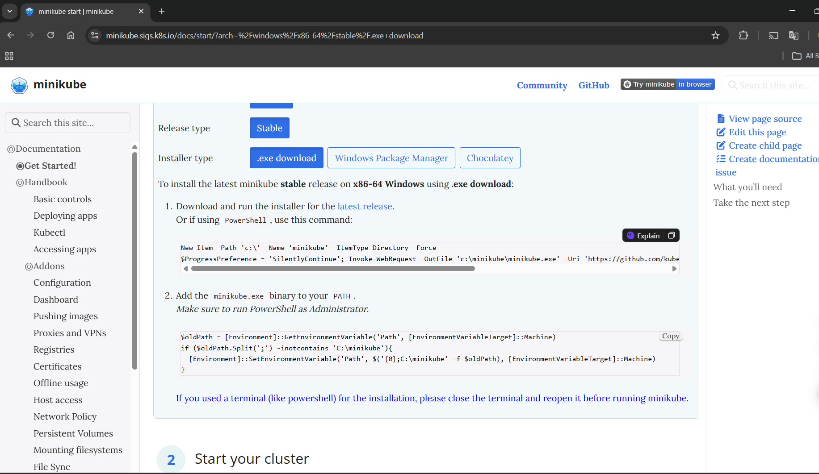Start:

minikube start

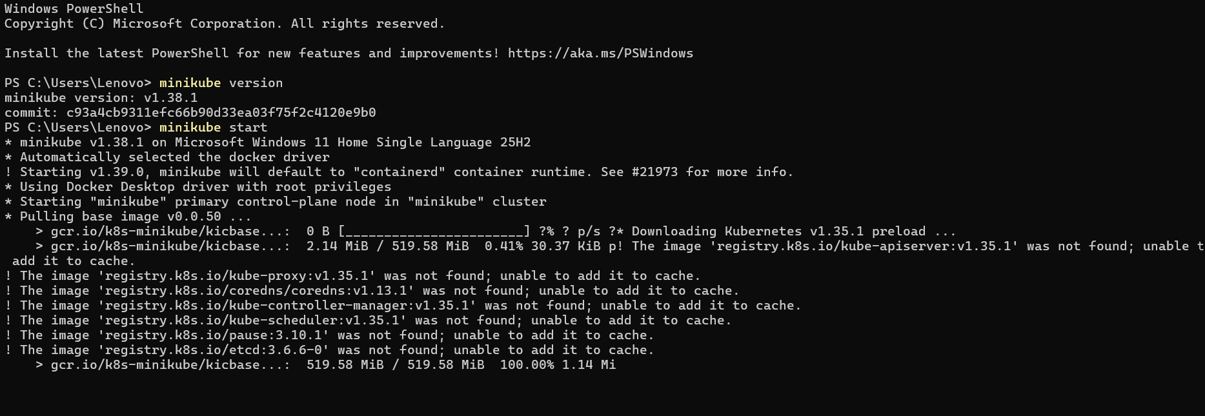

Useful Minikube Commands (Lab Ready)
Command | Purpose
minikube dashboard | Open K8s UI
minikube stop | Stop cluster
minikube delete | Delete cluster
minikube ssh | Access node
kubectl get pods -A | View all pods

